**Garden of the Gods**

Address: 1805 N 30th St, Colorado Spring, CO 80904, United States.

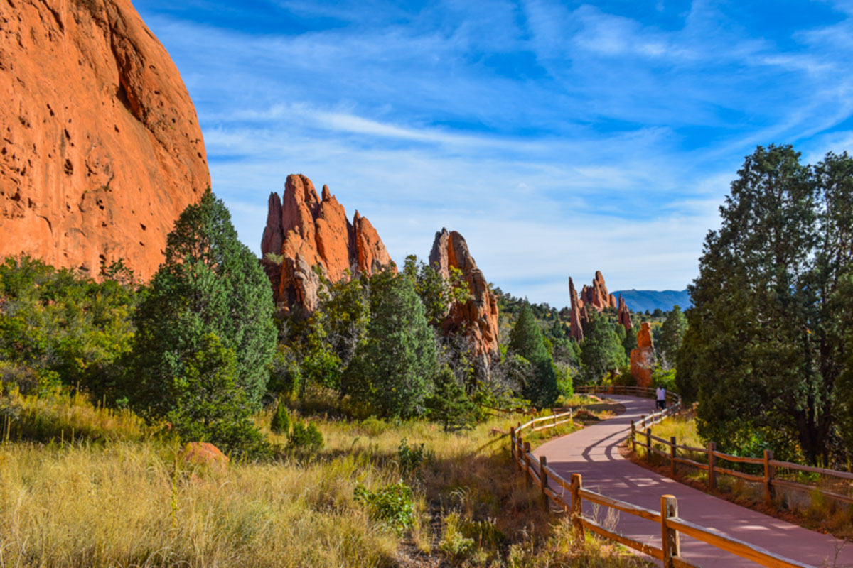

**Sand canyon, Mesa, Greenlee, Red Rock Canyon Loop**

Address for Sand canyon: 199-101 Bevers PI, Manitou Springs, CO 80829, United States.

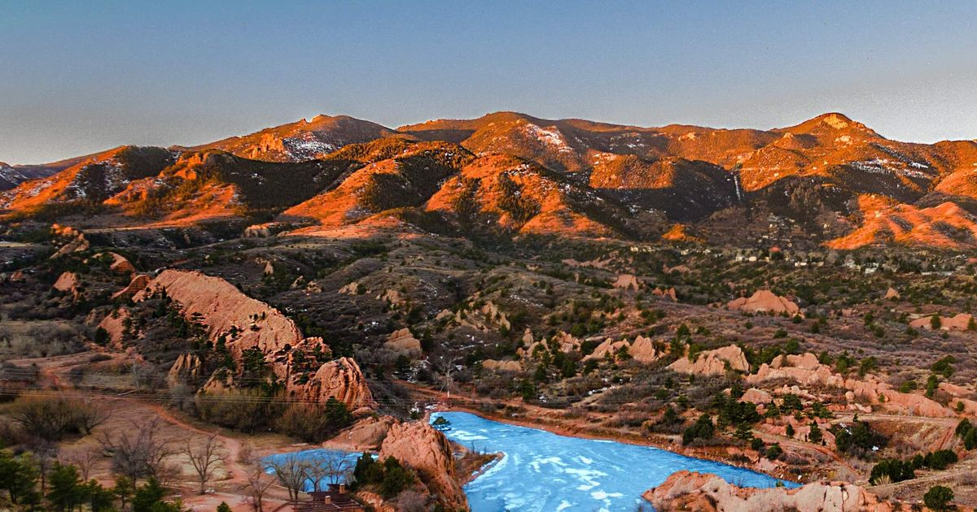

**3.Ouray Perimeter Trail**

Address: Perimeter Trail Trailhead, Fellin Park, Ouray, CO 81432

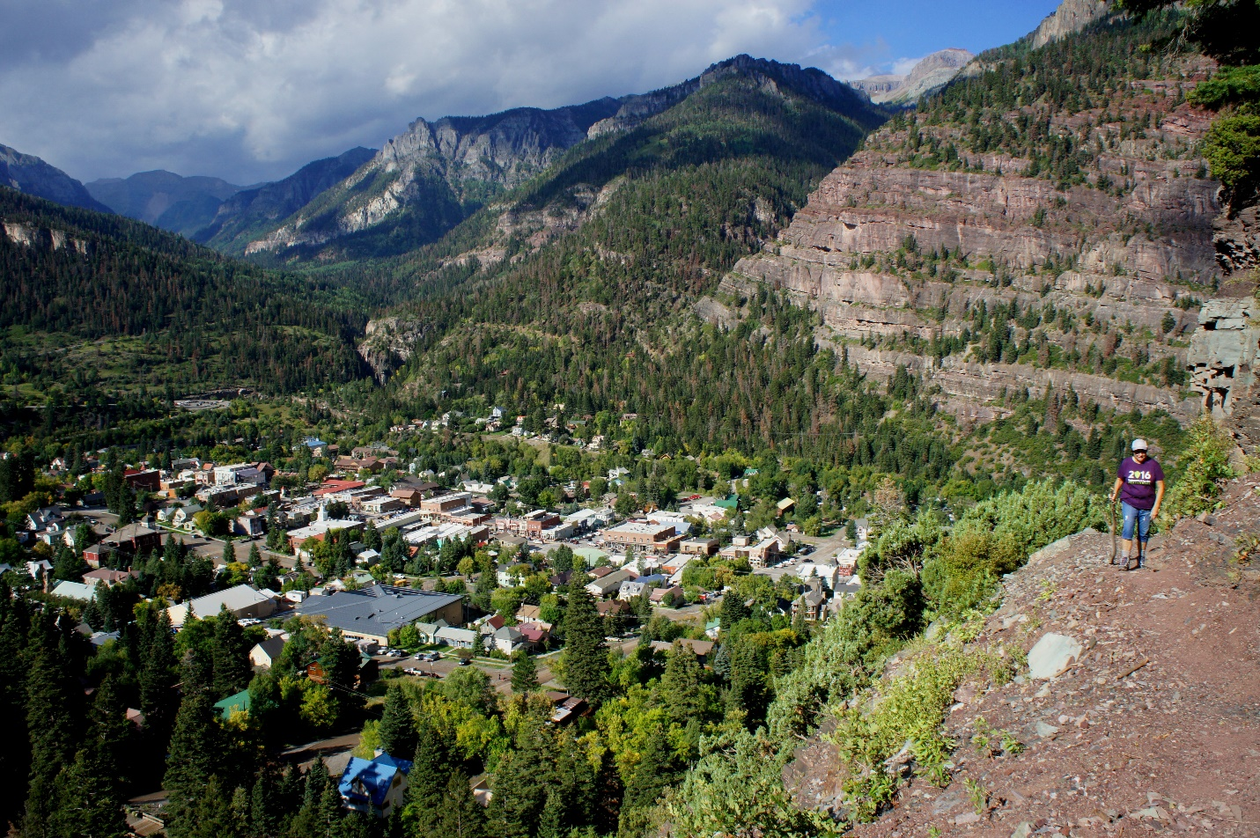

**4.Ice Lake Basin**

Address: Ice lake, San Juan County,Silverton, CO 81433

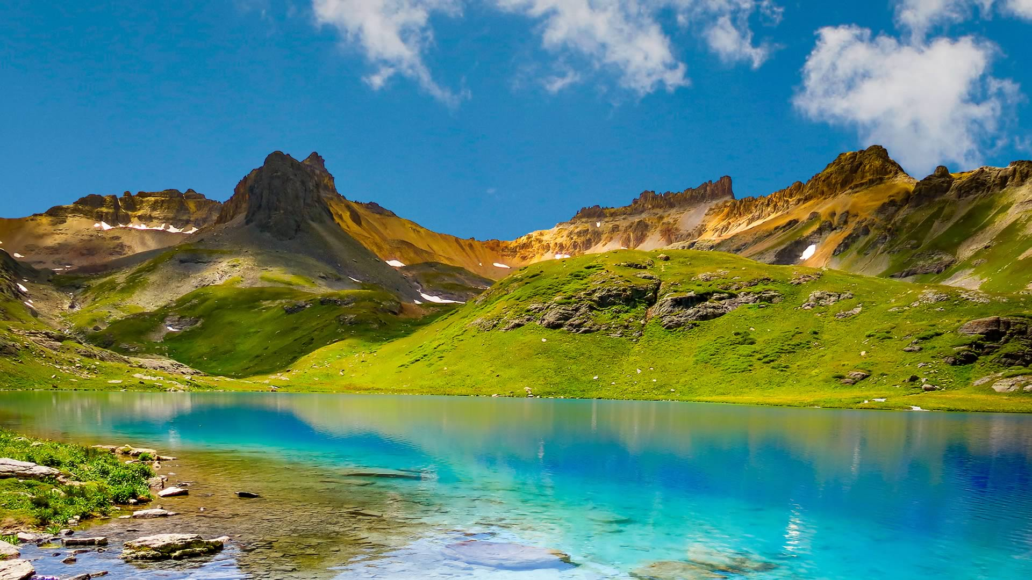

**5.The Manitou Incline:**

Address: 514 Ruxton Ave, Manitou Incline, CO 80829.

